RFQ Process For Self Engineered Items

- Select the Session “Released Technical Specification”
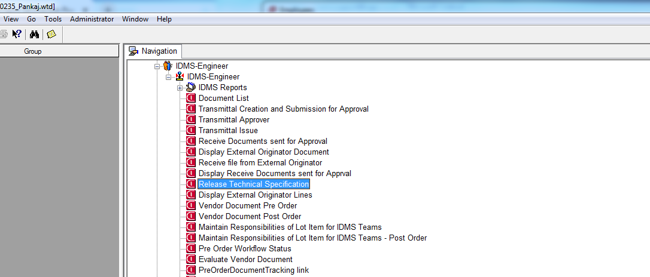
Select this session
- In the screen that open up select New Specification.
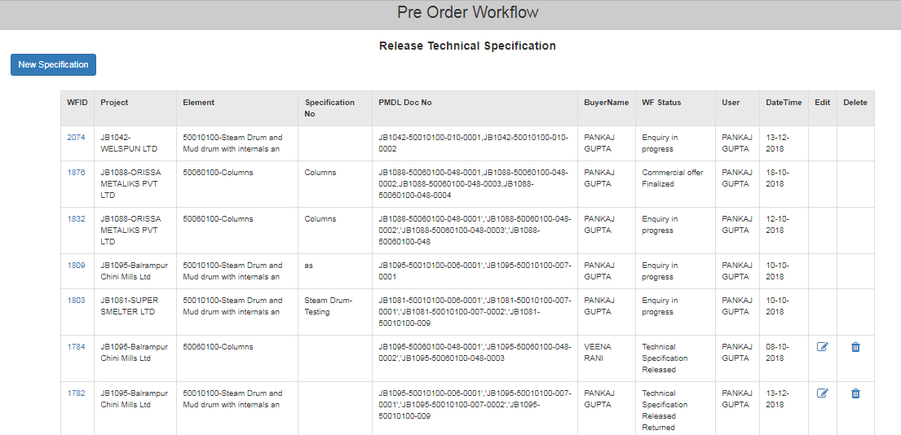
Press this Button

- In The Screen that Open up Fill up the Details as shown, then click on attachment
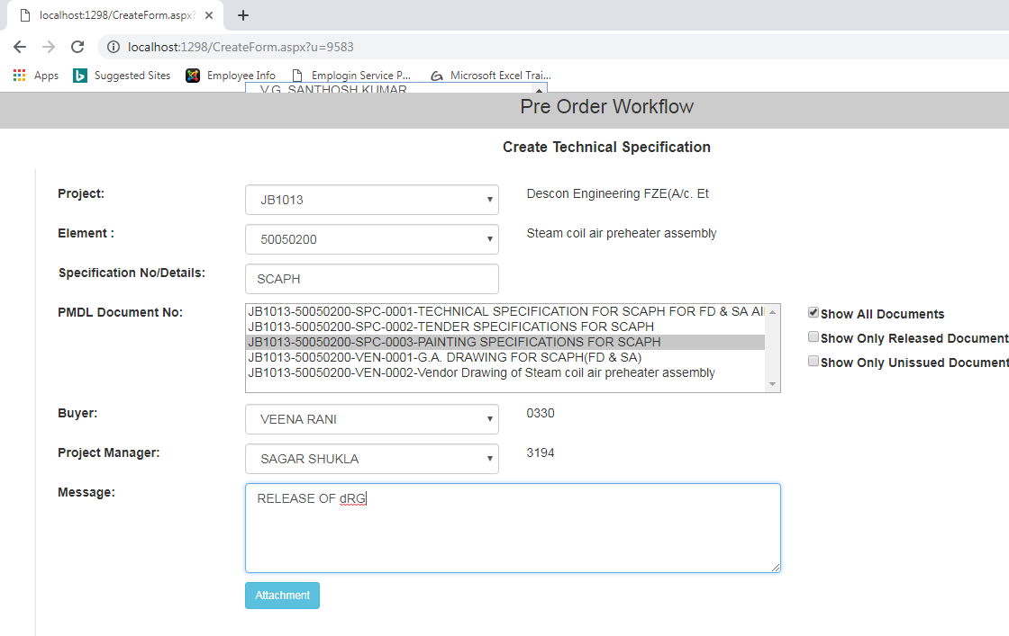
Click on Attachment
Fill Details

- In the screen that open up choose the path of the document/drawing & then select Upload attachment.
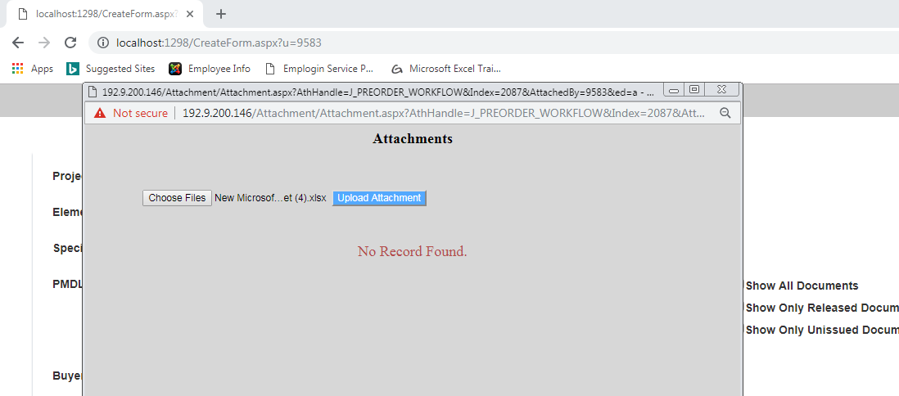
Upload Attachment
Path of File To
Attach

- Message is displayed Successfully Uploaded then press OK and close the screen.
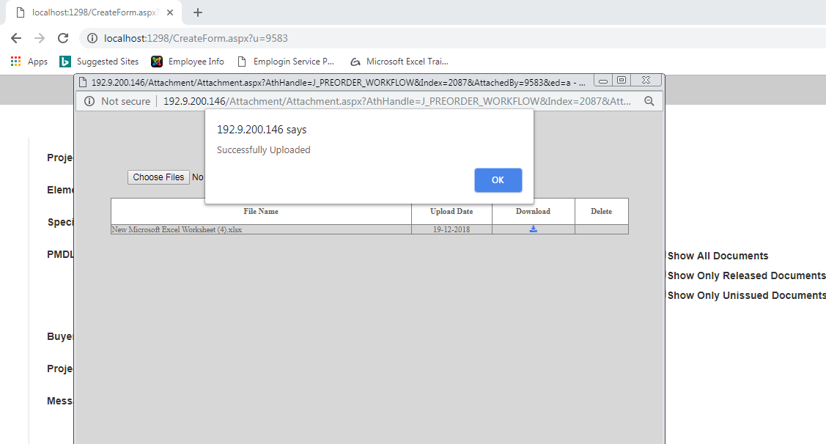
Press Ok

- Click on Release.
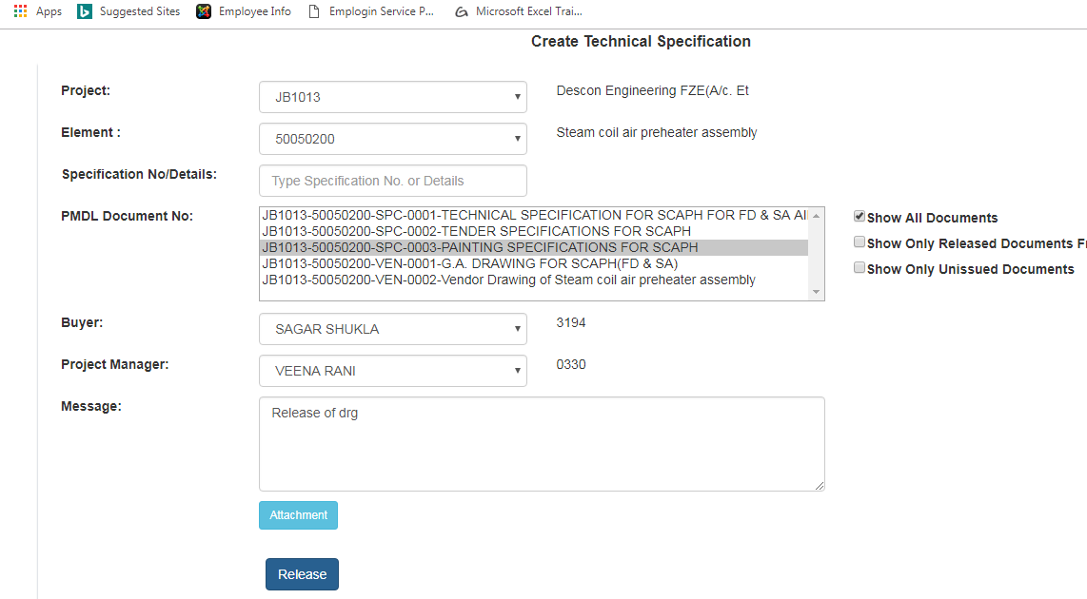
Select Release

- The Record will get populated in the screen with status Technical Specification Released. Close and Exit this session.
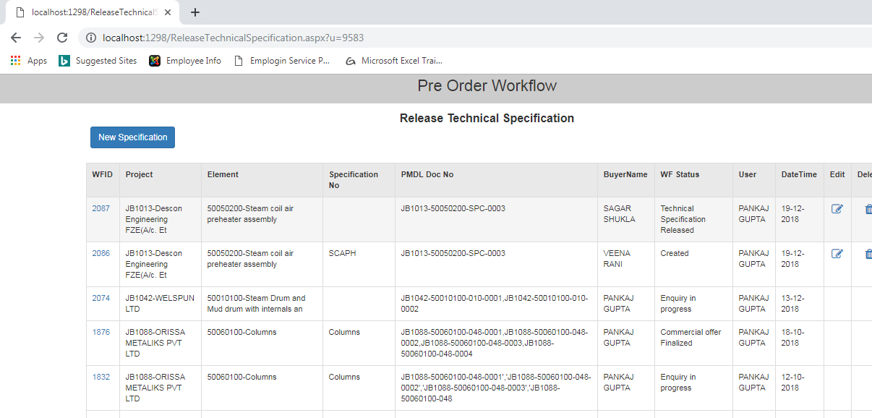
Record is populated

